**Mohammedmusthafa65203@gmail.com**

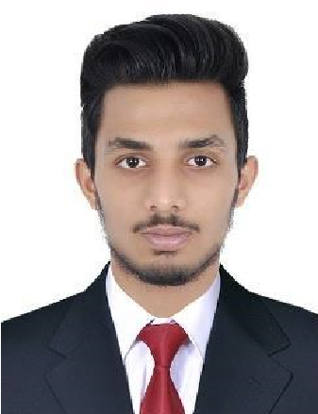

**Muham**

**m**

**e**

**d Mu**

**s**

**t**

**hafa**

**M**

**o**

**b N**

**o**

**: 7592040338**

**7592040338**

**E**

**m**

**a**

**i**

**l**

**:**

**a**

**i**

**.c**

**o**

**m**

# CAREER OBJECTIVE

Willing to go an extra mile to accomplish career and personal satisfaction, with compressive problem solving and fast learning abilities. Excellent communication skills and computer literate, ability to work under pressure, hardworking and responsible.

# EXPERIENCE AT SHARAF DG (DUBAI) MAY 2017- MAY 2018

**Responsibilities**

* Marketing and sales of all the digital products.
* Frequently contacting regular customers and enquiring their needs.
* Identifying and qualifying prospective customers through market research and networking.
* Making customers aware of the new products launched in the market.
* Engaged in active dialogue to diagnose customers needs and recommend appropriate solutions, ensuring a successful customer experience.
* Maintained store appearance through regular reorganization of store displays.
* Maintained positive attitude to make customers shopping experiences memorable and pleasant.
* Answered customer questions regarding store merchandise, department information, and pricing.

# EXPERIENCE AT AMAZON WAREHOUSE(DUBAI) JUNE 2018- NOV 2018

**Responsibilities**

* Ordering, receiving, storing, inventorying, inspecting and delivery of materials, supplies, tools, equipment or replacement parts through WMS (Warehouse Management System).
* unpacking and inspection of items to create NCR (Non Conformance Report).
* return defective, excessive, broken or incorrect items and process Damage Report or Return note, D.O.
* Maintains files indicating amount of individual items on hand at any given time in ERP.
* Maintains the distribution of all items as FIFO Method.
* Keeps Inventory Control closely correlated with Supervisor.
* Maintain cleanliness in warehouse and storage area on regular basis.
* Encourage and support the colleagues under timely manner for completion of given task under provided time for specific job as team work.

# OTHER EXPERIENCE

* Worked as a Geepas Promoter (2018)
* Worked as a Merchandiser for YuppTV in Karama Lulu (2018)
* Worked as a Exhibition Promoter for 3 days in Sharjah expo center (2018).
* Worked as a promoter for canon in GITEX, planning and promoting events (2017).
* Salesman | Fashion plus, Karama, Dubai (2017)

# EDUCATIONAL QUALIFICATION

* SSLC | The Central School (Dubai)

* Higher Secondary (Kerala)
* Airport Management | Flywings international college (Kerala)

# Computer Skills

* Software Applications: (MS Office, Libre Office)

* Data entry & Analytics

* Email & Social Media

* Operating System: (Windows, Mac OS)

# 

**PERSONAL PROFILE**

Date of Birth : 27-03-1999

Languages Known : English, Malayalam And Hindi

Residential Address : Al Fathah, Thalasshery, Kannur, Kerala.

Hobbies : Football, Typing and Reading .

**DECLARATION**

I hereby declare that all the information furnished above is true and correct.